**SQL Coding Challenge – Question Number 2**

**Name: S.Yazhini (DE130)**

**Date: 08-11-2024**

**Question:**

2.Manipulate data by using sql commands using groupby and having clause.

**Objective:**

* The main objective of this question is to understand the concepts of Groupby and having Clause
* This helps us to write a real time SQL query base on the problem and the datasets.

**Concepts Used**

* **GROUPBY:**
  + **Purpose**: GROUP BY organizes rows with identical values in specified columns into groups, enabling us to apply aggregate functions (e.g., SUM, COUNT, AVG, MAX, MIN) to each group.
  + **Usage**: Often used with aggregate functions to summarize data. Without GROUP BY, aggregate functions would apply to the entire dataset instead of specific subsets.
* **HAVING CLAUSE:**

**Purpose**: HAVING is used to filter groups created by the GROUP BY clause based on conditions applied to aggregate functions. It acts like a WHERE clause but specifically filters grouped (aggregated) data.

* + **Usage**: Often paired with GROUP BY, it allows for conditions like “only show groups where the total is above a certain value.”

**SQL QUERY:**

1. Find Categories with Total Sales Above a Certain Amount

This query calculates the total sales per category and filters to show only those categories with total sales exceeding 10,000.

SELECT pd.category_name,

SUM(s.qty * s.price) AS total_sales

FROM sales s

JOIN product_details pd ON s.prod_id = pd.product_id

GROUP BY pd.category_name

HAVING SUM(s.qty * s.price) > 10000;

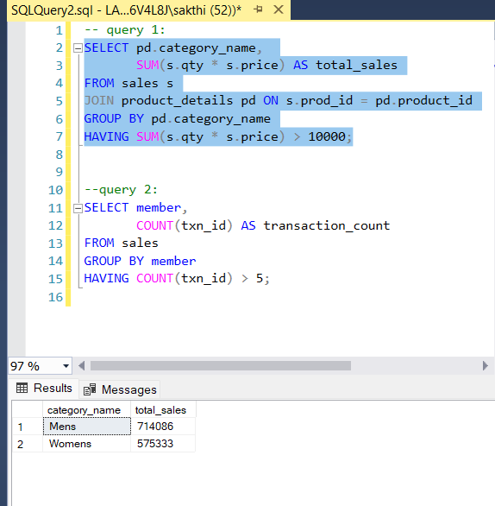

2. This query counts transactions by each member and filters to show only those members who have made more than 5 transactions.

SELECT member,

COUNT(txn_id) AS transaction_count

FROM sales

GROUP BY member

HAVING COUNT(txn_id) > 5;

